


Database Management Lab Experiment (ENCS205)

Bachelor of Technology in
Computer Science and Engineering

Submitted by
Sahdev sharma (2401010092)
B. Tech CSE (Core) – 4th Semester Section: A

Submitted To:
MS. Mansi Kajal

School of Engineering & Technology
K. R. MANGALAM UNIVERSITY
Sohna, Haryana 122103, India feb-2026

EXPERIMENT:10

Using the tables “DEPARTMENTS” and “EMPLOYEES” perform the following queries:
- Display the employee details, departments that the departments are same in both the emp and dept.
- Display the employee name and Department name by implementing a left outer join.
- Display the employee name and Department name by implementing a right outer join.
- Display the details of those who draw the salary greater than the average salary.

[QUERY]:
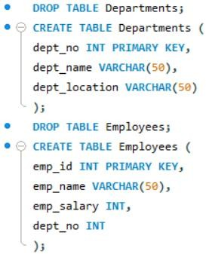

[Inserting records]:
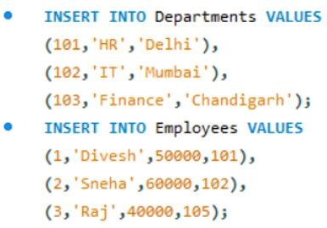

- Display the employee details, departments that the departments are same in both the emp and dept.
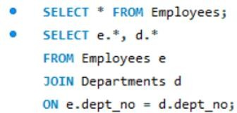
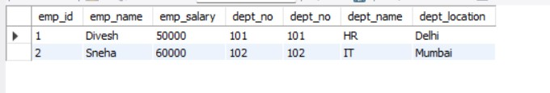

- Display the employee name and Department name by implementing a left outer join.
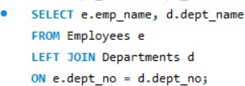
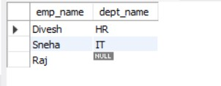

- Display the employee name and Department name by implementing a right outer join.

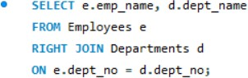
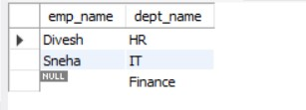

- Display the details of those who draw the salary greater than the average salary.
